CL3

CI

RPC

1. RPC in CI likely refers to "Remote Procedure Call (RPC) in Continuous Integration (CI)" when discussing software development practices.
2. Remote Procedure Call (RPC) is a protocol that allows a program to execute code in another address space (commonly on another computer) as if it were a local procedure call. It enables distributed applications to communicate and perform tasks across different systems.
3. Continuous Integration (CI) is a software development practice where code changes are automatically built, tested, and integrated into a shared repository multiple times a day. CI ensures that new code changes are regularly merged into a main branch, reducing integration issues and helping teams deliver software more rapidly and reliably.
4. Combining RPC with CI involves integrating remote procedure calls into a CI/CD (Continuous Integration/Continuous Deployment) pipeline. This can be useful in scenarios where:
5. Microservices Architecture: RPC can be used to facilitate communication between microservices during the CI process, ensuring that changes made to one microservice don't break the functionality of another.
6. Testing: RPC calls can be used to trigger and perform tests across distributed components or services as part of the CI pipeline. For example, one service might make RPC calls to invoke tests on another service.
7. Service Dependencies: CI pipelines can involve RPC to manage service dependencies during the build and deployment processes, ensuring that all required services are available and functioning correctly.
8. Build Orchestration: RPC can be used to trigger build processes on remote servers or environments, allowing for a more distributed and scalable CI setup.
9. To implement RPC in a CI environment:
10. Choose an RPC Framework: Select an appropriate RPC framework that supports the desired programming languages and integrates well with your CI/CD tools.
11. Define Service Interfaces: Clearly define the interfaces and contracts for the RPC calls that will be used within your CI processes.
12. Integrate with CI Tools: Incorporate RPC calls into your CI scripts or automation tools to orchestrate remote tasks, tests, or builds across distributed components.
13. Monitor and Debug: Implement logging and monitoring for RPC calls within your CI pipelines to facilitate debugging and performance optimization.
14. By leveraging RPC in a CI setup, development teams can enhance the scalability, flexibility, and reliability of their continuous integration and deployment workflows, particularly in distributed or microservices-based architectures.

RMI

RMI (Remote Method Invocation) in CI (Continuous Integration) refers to using Java's RMI technology within the context of a Continuous Integration (CI) environment. Let's break down what this entails:

Remote Method Invocation (RMI)

Remote Method Invocation (RMI) is a Java API that allows an object running in one Java virtual machine (VM) to invoke methods on an object running in another Java VM. It enables distributed Java applications to communicate and interact by invoking methods remotely.

In RMI, you have:

Remote Interface: Defines the methods that can be invoked remotely.

Remote Object: Implements the remote interface and provides the actual functionality that can be called remotely.

Registry: Acts as a lookup service where clients can find remote objects by name.

Continuous Integration (CI)

Continuous Integration (CI) is a software development practice where developers integrate their code changes into a shared repository frequently (often multiple times a day). With each integration, an automated build and test process is triggered to detect integration errors early.

Using RMI in CI

Integrating RMI into a CI pipeline can be beneficial for scenarios where you have distributed Java components or services that need to interact during the CI process. Here's how you might use RMI in CI:

Microservices Testing: If you have microservices written in Java that interact via RMI, you can use RMI in your CI pipeline to trigger tests that involve these services. This ensures that the interaction between microservices works as expected with each code change.

Remote Test Execution: You can use RMI to trigger remote test execution on specific environments or machines as part of your CI process. For instance, you might trigger a test suite on a dedicated test server via RMI.

Integration Testing: RMI can facilitate integration testing by allowing different components or modules to communicate and interact remotely during the CI build and test phase.

Steps to Use RMI in CI

To incorporate RMI into your CI setup:

Define Remote Interfaces: Define the remote interfaces that specify the methods available for remote invocation.

Implement Remote Objects: Implement the remote objects that provide the actual functionality behind the remote interfaces.

Set Up Registry: Start an RMI registry that acts as a lookup service for locating remote objects.

CI Build Script: Write your CI build script to compile, package, and deploy your RMI components as part of the CI pipeline.

Trigger Remote Tasks: Use RMI calls within your CI scripts to trigger remote tasks, tests, or interactions between distributed components.

Monitor and Debug: Implement logging and monitoring to track RMI interactions and facilitate debugging during CI runs.

Considerations

Firewall and Networking: Ensure that the necessary ports for RMI communication are accessible within your CI environment.

Security: Implement appropriate security measures (e.g., RMI security manager, SSL/TLS) to protect RMI communications, especially in distributed environments.

By incorporating RMI into your CI workflows, you can enhance the testing and integration of distributed Java applications, ensuring that remote components interact correctly and reliably with each code change.

MapReduce:

"MapReduce in CI" refers to utilizing the MapReduce programming model within the context of Continuous Integration (CI) practices. Let's break down what this means and how it can be applied:

MapReduce Overview

MapReduce is a programming model and framework originally developed by Google for processing and generating large-scale datasets in parallel across clusters of computers. It consists of two main phases:

Map Phase: In this phase, input data is divided into smaller chunks, and a map function is applied to each chunk independently to generate intermediate key-value pairs.

Reduce Phase: The intermediate key-value pairs produced by the map phase are grouped based on keys, and a reduce function is applied to each group to produce the final output.

MapReduce is designed to handle massive datasets efficiently by distributing the computation across multiple nodes in a cluster, making it suitable for big data processing tasks.

Continuous Integration (CI) Overview

Continuous Integration (CI) is a software development practice where developers frequently merge their code changes into a shared repository, and automated builds and tests are run on the integrated code. The goal is to detect and address integration issues early and ensure that the software is always in a releasable state.

Using MapReduce in CI

Integrating MapReduce into a CI pipeline can be valuable for scenarios where you need to process and analyze large datasets as part of your software testing or build processes. Here's how MapReduce can be applied in a CI environment:

Data Processing: If your application involves processing large volumes of data, you can use MapReduce to preprocess or transform this data during the CI process. For example, generating test data sets or extracting insights from logs.

Distributed Testing: MapReduce can be used to parallelize certain types of testing tasks that involve processing large datasets or simulating complex scenarios across distributed nodes. This can speed up testing and improve test coverage.

Build Optimization: MapReduce can optimize certain build tasks that can be decomposed into parallelizable units of work. For instance, parallelizing code analysis or dependency resolution.

Performance Testing: Utilize MapReduce to analyze performance metrics and bottlenecks across distributed components of your application during CI runs.

Steps to Use MapReduce in CI

To incorporate MapReduce into your CI workflow:

Identify MapReduce Tasks: Identify tasks within your CI pipeline that can benefit from parallel processing or large-scale data handling.

Implement Map and Reduce Functions: Write map and reduce functions tailored to the specific tasks you want to execute using the MapReduce paradigm.

Cluster Setup: Configure a cluster (local or cloud-based) where MapReduce tasks will be executed during CI runs.

Integration with CI Tools: Integrate MapReduce tasks into your CI scripts or automation tools to trigger and manage MapReduce jobs as part of the CI process.

Monitoring and Reporting: Implement monitoring and reporting mechanisms to track the progress and outcomes of MapReduce tasks during CI runs.

Considerations

Infrastructure Requirements: Ensure that you have access to suitable infrastructure (e.g., Hadoop cluster, cloud-based MapReduce services) to execute MapReduce tasks within your CI environment.

Data Management: Handle input and output data carefully, especially in distributed environments, to ensure data consistency and integrity.

Cost and Efficiency: Consider the cost implications of running MapReduce tasks in a cloud environment and optimize the usage to achieve cost-effective CI pipelines.

By leveraging MapReduce in your CI workflows, you can harness the power of distributed computing to enhance data processing, testing, and build optimization, particularly for applications that deal with large-scale data and complex computations.

***fuzzy relations by Cartesian product of any two fuzzy sets and perform max-min composition on any two fuzzy relations.***

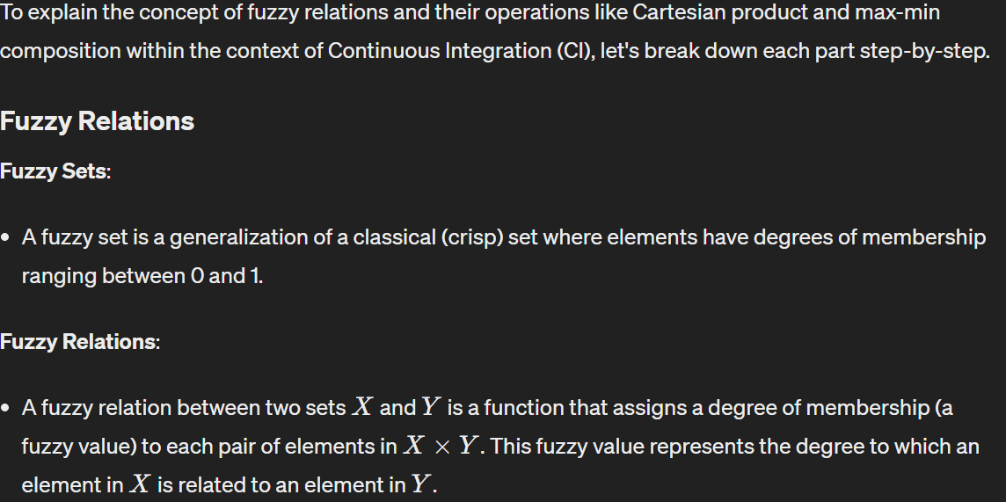

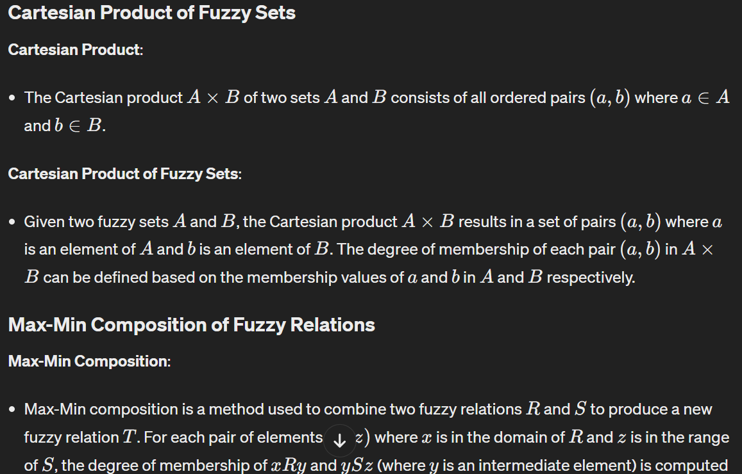

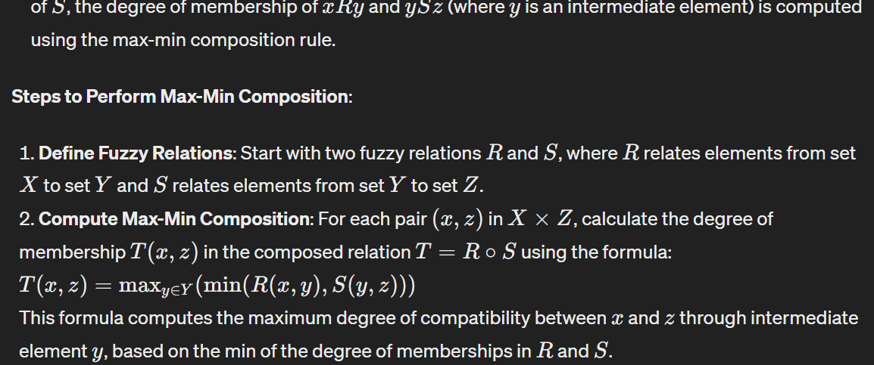

**load balancing algorithms**.

Load balancing algorithms play a crucial role in the context of Continuous Integration (CI) to distribute computational tasks efficiently across various nodes or resources within a CI infrastructure. Load balancing aims to optimize resource utilization, reduce response times, and ensure high availability of CI services. Here are some common load balancing algorithms and their relevance in CI environments:

1. Round Robin

Algorithm: The Round Robin algorithm cyclically distributes incoming tasks or requests equally among a set of resources in a sequential order.

Use in CI: Round Robin is simple to implement and ensures that tasks are distributed fairly across CI nodes or build agents. It can prevent resource starvation by evenly spreading the workload.

2. Least Connections

Algorithm: The Least Connections algorithm directs incoming tasks or requests to the node with the fewest active connections, aiming to distribute load based on current utilization.

Use in CI: This algorithm is effective for CI environments where nodes have varying capacities or response times. It helps in minimizing response time and prevents overloading of specific nodes.

3. Weighted Round Robin

Algorithm: Weighted Round Robin assigns a weight to each node based on its processing capacity. Nodes with higher weights receive a proportionally larger share of tasks.

Use in CI: In CI, nodes may have different hardware specifications or performance capabilities. Weighted Round Robin allows for more efficient utilization of resources by considering node capacities.

4. Random

Algorithm: The Random algorithm selects a node randomly from the pool of available nodes to handle each incoming task or request.

Use in CI: Random load balancing can be useful for distributing unpredictable workloads or when precise load balancing is less critical. However, it may not guarantee optimal resource utilization.

5. Least Response Time (or Fastest Response Time)

Algorithm: The Least Response Time algorithm directs tasks or requests to the node with the shortest response time based on historical data or real-time measurements.

Use in CI: This algorithm is beneficial for optimizing response times in CI pipelines, ensuring that tasks are processed efficiently and reducing overall build times.

6. IP Hash

Algorithm: The IP Hash algorithm uses a hash function based on the client's IP address to determine which node should handle a task or request. Requests from the same IP address are consistently directed to the same node.

Use in CI: IP Hash load balancing can be advantageous in CI setups where session persistence or affinity is required, ensuring that related tasks or requests are processed by the same node.

Integration into CI

Load balancing algorithms can be integrated into CI infrastructure through:

Load Balancers: Deploying dedicated load balancers (hardware or software-based) that implement various load balancing algorithms to distribute traffic across CI nodes or build agents.

Custom Scripts: Writing custom scripts or plugins within CI tools (e.g., Jenkins, GitLab CI) to implement specific load balancing logic based on workload characteristics, node capacities, or historical data.

Dynamic Scaling: Leveraging cloud-based CI platforms (e.g., AWS CodePipeline, Azure Pipelines) that support auto-scaling and dynamic resource allocation based on workload demands and load balancing policies.

Monitoring and Optimization: Continuously monitoring CI pipeline performance and optimizing load balancing strategies based on real-time metrics (e.g., CPU utilization, response times) to ensure efficient resource allocation and scalability.

Implementing effective load balancing algorithms in CI environments is essential for maintaining stability, scalability, and responsiveness of CI pipelines, especially in dynamic and distributed computing environments. By selecting and configuring appropriate load balancing strategies, CI processes can operate more reliably and efficiently, supporting continuous delivery and integration practices effectively.

Optimization of genetic algorithm parameter in hybrid genetic algorithm-neural network modelling: Application to spray drying of coconut milk.

Optimizing genetic algorithm parameters within the context of a hybrid genetic algorithm-neural network model, specifically applied to spray drying of coconut milk, involves several key steps and considerations. This process can be effectively integrated into a Continuous Integration (CI) environment to automate parameter tuning and model optimization. Here's a detailed guide on how to approach this:

1. Understand the Problem Domain

Before applying any optimization techniques, it's essential to thoroughly understand the problem domain, which in this case is the spray drying process of coconut milk. This involves:

Understanding the input variables (e.g., temperature, flow rate, concentration).

Defining the output or target variables (e.g., powder yield, moisture content).

Identifying key performance metrics for evaluating model accuracy and efficiency.

2. Develop the Hybrid Genetic Algorithm-Neural Network Model

Genetic Algorithm (GA) Component:

Define the genetic algorithm parameters:

Population size: Number of individuals in each generation.

Mutation rate: Probability of a gene mutating during crossover.

Crossover rate: Probability of two individuals exchanging genetic material.

Termination criteria: Conditions for stopping the genetic algorithm (e.g., maximum number of generations, convergence threshold).

Neural Network (NN) Component:

Design the neural network architecture:

Number of layers.

Number of neurons per layer.

Activation functions.

Optimization algorithm (e.g., Adam, SGD).

Loss function (e.g., mean squared error, categorical cross-entropy).

3. Define the Optimization Problem

The goal is to optimize the performance of the hybrid model in predicting spray drying outcomes. This involves:

Formulating an objective function to be minimized or maximized (e.g., minimize prediction error, maximize powder yield).

Determining the ranges and constraints of genetic algorithm parameters to be optimized.

4. Implement Optimization in a CI Pipeline

Integrating parameter optimization into a Continuous Integration (CI) pipeline allows for automated testing and validation of different parameter configurations. Here's how you can do it:

Setup CI Environment:

Use CI tools (e.g., Jenkins, GitLab CI/CD) to automate the testing and deployment of your hybrid model.

Configure CI jobs to trigger parameter optimization tasks based on predefined schedules or events (e.g., new code commits, nightly builds).

Implement Parameter Optimization:

Utilize hyperparameter optimization techniques (e.g., grid search, random search, Bayesian optimization) within the genetic algorithm to search for optimal parameter values.

Develop scripts or modules to execute parameter optimization tasks as part of the CI pipeline.

Monitor and Evaluate Results:

Integrate logging and monitoring mechanisms to track the progress of parameter optimization.

Evaluate the performance of different parameter configurations using cross-validation or other validation techniques.

5. Ensure Scalability and Reproducibility

Make sure that the optimization process is scalable and reproducible across different environments and datasets:

Use containerization tools (e.g., Docker) to encapsulate the entire CI pipeline and ensure consistent behavior across different computing environments.

Version control all code and configuration files to track changes and enable reproducibility of experiments.

6. Iterate and Refine

Iteratively refine the hybrid model and genetic algorithm parameters based on evaluation results and domain expertise:

Analyze optimization outcomes to identify trends and patterns.

Incorporate feedback from domain experts to fine-tune model parameters and improve prediction accuracy.

Conclusion

Optimizing genetic algorithm parameters in a hybrid genetic algorithm-neural network model for spray drying of coconut milk requires a systematic approach integrating model development, optimization, and evaluation within a Continuous Integration (CI) environment. By automating parameter tuning and leveraging CI tools, you can streamline the optimization process and accelerate model development for real-world applications.

**Clonal selection algorithm**

The Clonal Selection Algorithm (CSA) is a computational optimization algorithm inspired by the natural immune system's process of clonal selection and affinity maturation. It is particularly effective for solving optimization problems, especially in domains where adaptation and learning are essential. The CSA is part of the broader field of artificial immune systems (AIS) and has been successfully applied to various optimization tasks.

Key Concepts of Clonal Selection Algorithm (CSA)

Antibody Representation:

In CSA, an antibody represents a potential solution to the optimization problem. It is encoded as a vector of parameters that can be mutated and evolved during the algorithm's execution.

Clonal Expansion:

The algorithm starts with a set of initial antibodies (solutions). Antibodies with higher fitness (better solutions) are selected for clonal expansion based on their affinity to the problem's objective function.

Affinity Maturation:

During clonal expansion, antibodies are replicated with a rate proportional to their affinity (fitness) to the problem's objective. This process mimics the immune system's ability to produce more copies of effective antibodies.

Mutation and Selection:

Newly cloned antibodies undergo mutation to introduce diversity into the population. After mutation, a selection process occurs to retain the fittest antibodies while eliminating weaker ones.

Steps of Clonal Selection Algorithm

The typical steps involved in implementing the Clonal Selection Algorithm are as follows:

Initialization:

Generate an initial population of antibodies (solutions) randomly or based on domain-specific knowledge.

Evaluation:

Evaluate each antibody's fitness (objective value) based on the problem's objective function.

Clonal Selection:

Select antibodies for cloning based on their affinity (fitness). Antibodies with higher fitness are more likely to be selected for clonal expansion.

Clonal Expansion:

Replicate selected antibodies (clones) proportionally to their affinity. Higher-affinity antibodies produce more clones.

Mutation:

Introduce mutations (random changes) into the cloned antibodies to create diversity in the population.

Selection:

Evaluate the fitness of mutated antibodies and select the fittest ones to form the next generation.

Termination:

Repeat the process for a fixed number of iterations or until a convergence criterion is met (e.g., maximum number of generations, satisfactory solution quality).

Advantages of Clonal Selection Algorithm

Exploration and Exploitation: CSA balances exploration (creating diversity through mutation) and exploitation (selecting fittest solutions) effectively.

Adaptability: The algorithm can adapt to dynamic environments or complex search spaces.

No Gradient Information Required: Unlike traditional optimization methods, CSA does not require gradient information, making it suitable for non-convex and discontinuous optimization problems.

Applications of Clonal Selection Algorithm

The Clonal Selection Algorithm has been successfully applied to various optimization problems, including:

Function Optimization: Finding the global optimum of multimodal and complex functions.

Pattern Recognition: Feature selection and classification tasks.

Machine Learning: Model selection, hyperparameter tuning, and reinforcement learning.

Engineering Design: Parameter optimization in engineering systems and processes.

Conclusion

The Clonal Selection Algorithm is a powerful optimization technique inspired by the immune system's natural processes. Its ability to strike a balance between exploration and exploitation makes it suitable for a wide range of optimization problems, including those encountered in machine learning, engineering, and computational biology. By leveraging principles from the immune system, CSA offers a robust and adaptive approach to solving complex optimization challenges.

**Neural style transfer**

Neural style transfer is a fascinating technique in the field of deep learning that allows you to combine the content of one image with the style of another image, resulting in a new image that retains the semantic content of the original content image but is rendered in the artistic style of the style image. This process is achieved using convolutional neural networks (CNNs) and optimization algorithms. Let's delve into the details of how neural style transfer works:

Key Concepts in Neural Style Transfer

Content and Style Representation:

The "content" of an image refers to the high-level structure and objects present in the image.

The "style" of an image refers to the textures, colors, and visual patterns that characterize the artistic style of the image.

Neural Network Architecture:

Neural style transfer typically involves using a pre-trained convolutional neural network (CNN), such as VGG (Visual Geometry Group) network, to extract both content and style features from images.

Loss Functions:

Content Loss: Measures the difference in content between the generated image and the content image using feature maps extracted from a selected layer of the CNN.

Style Loss: Captures the difference in style between the generated image and the style image using Gram matrices of feature maps from multiple layers of the CNN.

Steps Involved in Neural Style Transfer

Preparation:

Choose a content image (e.g., a photograph) and a style image (e.g., a painting) that you want to combine.

Load a pre-trained CNN (e.g., VGG) and select specific layers to extract content and style features.

Feature Extraction:

Pass the content image and style image through the CNN to extract content features (from a chosen content layer) and style features (from multiple style layers).

Initialization:

Initialize a third image (the generated image) with random pixel values or by copying the content image.

Optimization:

Use an optimization algorithm (e.g., L-BFGS, Adam) to iteratively modify the generated image to minimize a combined loss function that consists of:

Content Loss: Measures the difference in content features between the generated image and the content image.

Style Loss: Measures the difference in style features between the generated image and the style image.

Update the generated image to minimize the overall loss.

Output:

The optimization process continues until convergence (or a predetermined number of iterations).

The final generated image combines the content of the content image with the style of the style image.

Applications and Variants

Artistic Rendering: Create artistic renditions of photographs using famous painting styles.

Image Manipulation: Apply custom styles to images for creative purposes.

Interactive Applications: Develop real-time style transfer applications for video and live camera feeds.

Implementing Neural Style Transfer

You can implement neural style transfer using deep learning frameworks such as TensorFlow or PyTorch. Several open-source implementations and tutorials are available to help you get started:

TensorFlow: Use the tf.keras.applications module with pre-trained VGG models.

PyTorch: Utilize the torch.nn.functional library for feature extraction and loss calculation.

Considerations and Challenges

Computational Cost: Neural style transfer can be computationally intensive, especially when using high-resolution images or complex style representations.

Parameter Tuning: Experiment with different hyperparameters (e.g., content/style weights, number of optimization iterations) to achieve desirable results.

Artistic Interpretation: The effectiveness of style transfer is subjective and may vary depending on the choice of content and style images.

Neural style transfer is a captivating application of deep learning that bridges the gap between artistic expression and computational creativity. By leveraging the power of convolutional neural networks and optimization techniques, you can create visually compelling images that blend content and style in unique ways**.**

**DISTRIBUTED COMPUTING**

**ARTIFICIAL IMMUNE SYSTEM:**

Artificial Immune System (AIS) approaches, including those involving pattern recognition, are inspired by the natural immune system's ability to detect and respond to foreign entities or anomalies within the body. Applying AIS to tasks like structure damage classification involves simulating immune-inspired processes to identify and classify patterns indicative of structural damage. Here's how you can approach this using an artificial immune pattern recognition system:

1. Problem Definition and Data Collection

Define the task of structure damage classification, such as identifying different types of damage (e.g., cracks, corrosion, fractures) in structural components (e.g., buildings, bridges, pipelines). Collect a dataset of labeled images or sensor data representing different types of structural damage.

2. Representation of Antigens (Patterns)

In the context of AIS, structural damage patterns are represented as "antigens" that the artificial immune system will recognize and classify. Each pattern (e.g., image patch, sensor signal) is encoded as a feature vector.

3. Designing the Artificial Immune System (AIS)

a. Antigen Representation

Represent structural damage patterns as antigens in the immune system. Use feature extraction techniques (e.g., image descriptors, signal processing methods) to encode structural damage patterns into numerical representations.

b. Immune Response Mechanisms

Define how the artificial immune system detects and responds to antigens:

Clonal Selection: Generate a diverse population of "antibodies" (representing detectors) that can bind to antigens.

Affinity Maturation: Select antibodies with high affinity (matching) to specific damage patterns.

Memory Cells: Retain information about encountered antigens to improve recognition over time.

c. Learning and Adaptation

Implement learning and adaptation mechanisms inspired by immunological principles:

Self-Nonself Discrimination: Train the system to distinguish between normal (healthy) patterns and abnormal (damaged) patterns.

Feedback Loop: Incorporate feedback from classification outcomes to update the immune response (e.g., adjust affinity thresholds, generate new antibodies).

4. Training and Classification

Train the artificial immune system using supervised learning techniques:

Training Dataset: Split the dataset into training and validation sets.

Pattern Recognition: Use labeled examples to train the immune system to recognize and classify different types of structural damage.

Evaluation: Assess the performance of the system using metrics such as accuracy, precision, recall, and F1-score.

5. Implementation and Integration

Implement the AIS-based pattern recognition system:

Use programming languages and frameworks suitable for machine learning and pattern recognition (e.g., Python with scikit-learn, TensorFlow, PyTorch).

Integrate the AIS system into the overall structure damage classification pipeline, including data preprocessing, feature extraction, and model training.

6. Testing and Deployment

Test the trained model on unseen data to evaluate its generalization performance:

Assess how well the artificial immune system can classify new instances of structural damage.

Deploy the system in real-world scenarios, such as monitoring infrastructure health or assisting in structural maintenance and inspection tasks.

Considerations and Challenges

Feature Engineering: Effective representation of structural damage patterns as feature vectors is critical for the performance of the AIS system.

Model Interpretability: Understandability of the immune-inspired classification process for stakeholders and domain experts.

Computational Complexity: AIS algorithms can be computationally intensive, requiring efficient implementation and optimization techniques.

Conclusion

Artificial Immune System (AIS) approaches offer a bio-inspired methodology for pattern recognition tasks such as structure damage classification. By mimicking the principles of the natural immune system, AIS can effectively detect and classify complex patterns indicative of structural damage, providing a valuable tool for infrastructure monitoring, maintenance, and inspection.

**DEAP**

DEAP (Distributed Evolutionary Algorithms in Python) is a powerful and versatile framework for building and experimenting with evolutionary algorithms (EAs) in Python. It provides a wide range of tools and functionalities to facilitate the development of evolutionary computation applications, including genetic algorithms, genetic programming, and other evolutionary techniques. Let's explore the key features and components of DEAP:

Key Features of DEAP

Genetic Algorithms (GAs):

DEAP allows you to implement genetic algorithms for optimization and search problems.

You can define custom representations (e.g., bitstrings, lists, trees) for candidate solutions (individuals) and specify genetic operators (selection, crossover, mutation) to evolve populations of individuals.

Genetic Programming (GP):

DEAP supports genetic programming, a technique for evolving computer programs to solve complex problems.

You can define function sets, terminals, and specify evolutionary operators (crossover, mutation) for evolving programs represented as trees.

Parallel and Distributed Computing:

DEAP includes features for parallel and distributed evaluation of individuals, enabling efficient optimization on multi-core CPUs or distributed computing environments (e.g., clusters).

Flexible Framework:

DEAP is designed to be flexible and extensible, allowing users to easily customize algorithms, representations, and evolutionary operators.

It provides a modular structure that facilitates experimentation with different components of evolutionary algorithms.

Integration with NumPy:

DEAP seamlessly integrates with NumPy, a popular numerical computing library in Python, for efficient handling of data arrays and vectorized operations within evolutionary algorithms.

Components of DEAP

Creator:

Allows the user to define custom data structures (e.g., individuals, fitness) for representing solutions to the optimization problem.

Toolbox:

Provides a container (toolbox) for evolutionary operators (selection, crossover, mutation) and methods for defining the evolutionary process.

Operators and methods can be combined and configured to create custom evolutionary algorithms.

Base Classes:

Defines base classes for evolutionary algorithms, individuals, and fitness evaluation.

Users can subclass these base classes to implement custom evolutionary components.

Algorithms:

DEAP includes implementations of popular evolutionary algorithms (e.g., NSGA-II, CMA-ES) that can be readily used for optimization tasks.

Statistics and Logging:

Provides tools for logging and analyzing evolutionary progress, including tracking statistics such as fitness values and generation-wise data.

**Ant colony optimization**

Ant Colony Optimization (ACO) is a metaheuristic optimization algorithm inspired by the foraging behavior of real ants. ACO is particularly effective for solving combinatorial optimization problems, such as the Traveling Salesman Problem (TSP), vehicle routing problems, and graph-based optimization tasks. The algorithm is based on the concept of simulating how ants discover and navigate through paths to find the shortest route between their nest and a food source. Here's how ACO works and how you can apply it to solve optimization problems:

Key Concepts of Ant Colony Optimization (ACO)

Ant Behavior Simulation:

In real life, ants deposit pheromone trails on the ground as they move, which serves as a form of communication to guide other ants towards food sources.

ACO mimics this behavior by using artificial ants to explore solution spaces and deposit virtual pheromone trails on paths.

Solution Representation:

ACO represents potential solutions as paths or sequences of decisions (e.g., city sequences in TSP).

Each ant constructs a solution by iteratively choosing components (e.g., edges, nodes) based on pheromone levels and heuristic information.

Pheromone Update:

Pheromone levels are updated based on the quality of solutions found by ants.

Good solutions receive stronger pheromone reinforcement, while poor solutions evaporate over time.

Exploitation and Exploration:

ACO balances exploitation (following strong pheromone trails to exploit known good solutions) and exploration (encouraging ants to try new paths) through adjustable parameters like pheromone evaporation rate and exploration probability.

Steps Involved in Ant Colony Optimization (ACO)

Initialization:

Initialize pheromone levels on paths and set up parameters such as the number of ants, pheromone evaporation rate, and heuristic information.

Ant Movement:

Each ant constructs a solution by iteratively selecting components based on pheromone levels and heuristic values.

The selection of components can be probabilistic, biased towards paths with higher pheromone levels and/or better heuristic values.

Solution Evaluation:

Evaluate the quality of solutions constructed by ants based on an objective function (e.g., total distance in TSP).

Pheromone Update:

Update pheromone levels on paths based on the quality of solutions.

Good solutions reinforce pheromone trails, while poor solutions lead to pheromone evaporation.

Termination:

Repeat the process for a specified number of iterations or until a convergence criterion is met (e.g., maximum number of iterations without improvement).

Applications of Ant Colony Optimization (ACO)

Traveling Salesman Problem (TSP): Finding the shortest tour that visits each city exactly once.

Vehicle Routing Problems (VRP): Optimizing delivery routes to minimize transportation costs.

Job Scheduling: Assigning tasks to resources to optimize schedule efficiency.

Network Routing: Finding optimal paths in communication networks.

**DEEP LEARNING:**

Linear Regression Model IN DL:

Linear regression is a fundamental technique used in traditional statistical modeling to establish a relationship between a dependent variable (target) and one or more independent variables (features). While deep learning (DL) is often associated with complex neural network architectures, it's important to note that linear regression can also be considered a simple form of a neural network, specifically a single-layer neural network with no activation function. In this context, I'll explain how linear regression can be implemented using deep learning frameworks like TensorFlow or PyTorch.

Linear Regression in Deep Learning

In deep learning, linear regression can be represented as a single-layer neural network with a linear activation function (also known as the identity activation function). The goal is to learn the weights (coefficients) and biases that best fit the training data to minimize the prediction error (typically using mean squared error).

Linear regression, although a basic statistical technique, can be implemented within the framework of deep learning using libraries like TensorFlow and PyTorch. By representing linear regression as a simple neural network model with linear activation, you can leverage the capabilities of deep learning frameworks to train, optimize, and make predictions efficiently. This approach also sets the foundation for more complex neural network architectures used in deep learning for tasks such as classification, regression, and more advanced modeling tasks.

To build a multiclass classifier using a Convolutional Neural Network (CNN) model and evaluate its performance using a confusion matrix, we'll walk through the process step-by-step using Python and TensorFlow/Keras. This example will demonstrate how to train a CNN on a dataset with multiple classes and then use the confusion matrix to evaluate the model's performance in terms of class-wise accuracy and errorMulticlass classifier using the CNN model and confusion matrix.

CONFUSION MATRIX:

A confusion matrix is a useful tool for evaluating the performance of a classification model. It allows us to visualize the performance of a machine learning algorithm by summarizing the counts of true positive, true negative, false positive, and false negative predictions on a per-class basis. Each row of the confusion matrix represents the instances in an actual class, while each column represents the instances in a predicted class.

Components of a Confusion Matrix

Let's break down the components of a confusion matrix:

True Positive (TP): The number of instances that belong to a particular class and are correctly predicted as belonging to that class.

True Negative (TN): The number of instances that do not belong to a particular class and are correctly predicted as not belonging to that class. This is mainly applicable in binary classification.

False Positive (FP): The number of instances that do not belong to a particular class but are incorrectly predicted as belonging to that class. Also known as a Type I error.

False Negative (FN): The number of instances that belong to a particular class but are incorrectly predicted as not belonging to that class. Also known as a Type II error.

Layout of a Confusion Matrix

For a binary classification problem, the confusion matrix is a 2x2 matrix structured as follows:

Predicted Positive Predicted Negative

Actual Positive True Positive (TP) False Negative (FN)

Actual Negative False Positive (FP) True Negative (TN)

For a multiclass classification problem with N classes, the confusion matrix is an N x N matrix, where each row corresponds to the true class and each column corresponds to the predicted class.

Using the Confusion Matrix

Diagonal Elements (TP and TN): The diagonal elements of the confusion matrix represent correct predictions for each class.

Off-diagonal Elements (FP and FN): The off-diagonal elements represent incorrect predictions, where the predicted class does not match the actual class.

Performance Metrics:

Accuracy: Overall accuracy of the model, calculated as (TP + TN) / (TP + TN + FP + FN).

Precision: The proportion of true positive predictions among all positive predictions, calculated as TP / (TP + FP).

Recall (Sensitivity): The proportion of true positive predictions among all actual positive instances, calculated as TP / (TP + FN).

Specificity: The proportion of true negative predictions among all actual negative instances, calculated as TN / (TN + FP).

F1-Score: The harmonic mean of precision and recall, calculated as 2 * (Precision * Recall) / (Precision + Recall).

Interpreting the Confusion Matrix

By examining the confusion matrix, you can gain insights into the model's performance across different classes. Key observations include:

The distribution of correct and incorrect predictions per class.

Identification of classes with high accuracy and those that are commonly misclassified.

Calculation of specific performance metrics (precision, recall) for each class.

RNN USING LSTM OR GRU

Recurrent Neural Networks (RNNs), including variants such as Long Short-Term Memory (LSTM) and Gated Recurrent Unit (GRU), are specialized neural network architectures designed to effectively model sequential data. They are particularly well-suited for tasks involving time-series data, natural language processing, speech recognition, and more. In this response, I'll explain the basic concepts of RNNs and delve into the specifics of LSTM and GRU, highlighting their differences and applications.

Recurrent Neural Networks (RNNs)

Traditional feedforward neural networks process fixed-size inputs and do not maintain memory between inputs. In contrast, RNNs have loops within their architectures, allowing them to maintain state information over time. This makes them suitable for sequence prediction tasks where previous inputs are relevant for predicting subsequent outputs.

**LSTM:**

**Long Short-Term Memory (LSTM)**

LSTM is a variant of RNN designed to address the vanishing gradient problem and capture long-term dependencies more effectively. It introduces specialized memory cells with gates that control the flow of information, allowing the network to retain information over long sequences.

Components of an LSTM Cell

An LSTM cell consists of several components:

Cell State ​: Represents the memory of the cell.

Forget Gate: Controls which information to discard from the cell state.

Input Gate: Determines which new information to store in the cell state.

Output Gate: Filters the information from the cell state to produce the output.

The computations in an LSTM cell are governed by these gates, which are controlled by learned parameters.

**Gated Recurrent Unit (GRU**)

GRU is another variant of RNN that simplifies the architecture of LSTM while achieving comparable performance. It combines the forget and input gates into a single "update gate" and merges the cell state and hidden state, resulting in a more streamlined design.

Simplified Structure of a GRU Cell

A GRU cell comprises:

Update Gate: Controls how much of the previous state to retain.

Reset Gate: Determines how much of the previous state to forget.

Candidate State: A proposed update to the state based on the input and previous state.

Applications

Natural Language Processing (NLP): RNNs, LSTM, and GRU are widely used for tasks like sentiment analysis, machine translation, and text generation.

Time Series Prediction: RNNs excel at modeling and predicting sequential data such as stock prices or weather patterns.

Speech Recognition: LSTM and GRU networks are employed in speech recognition systems to process audio data over time.

**CNN for Image Classification**

Convolutional Neural Networks (CNNs) are particularly well-suited for image classification tasks due to their ability to capture spatial hierarchies and local patterns within images. In this response, I'll explain the fundamental concepts of CNNs for image classification and provide a step-by-step guide on how to implement a basic CNN using TensorFlow/Keras for this purpose.

CNN Architecture Overview

CNNs consist of multiple layers, including convolutional layers, pooling layers, and fully connected layers. The primary components of a CNN are:

Convolutional Layer: Applies learnable filters to input images to extract features. Each filter performs a convolution operation, producing feature maps that capture local patterns.

Pooling Layer: Reduces the spatial dimensions of the feature maps, reducing computational complexity and controlling overfitting.

Activation Function: Introduces non-linearity into the model, allowing it to learn complex relationships between features.

Fully Connected (Dense) Layer: Applies a transformation to the extracted features to produce the final classification output.

Understanding the CNN Model Architecture

Conv2D Layers: Each Conv2D layer applies a set of learnable filters to the input image, capturing local patterns and features.

MaxPooling2D Layers: MaxPooling2D layers downsample the feature maps by taking the maximum value in each window, reducing spatial dimensions.

Flatten Layer: Flatten layer reshapes the 2D feature maps into a 1D vector for input to the fully connected layers.

Dense (Fully Connected) Layers: The Dense layers process the flattened features to perform the final classification using softmax activation for multiclass classification.

Visualizing Model Performance

After training, you can evaluate the model's performance on the test dataset and visualize the training/validation accuracy over epochs to monitor model training and detect overfitting.

Conclusion

Building a CNN for image classification involves defining the model architecture, compiling the model, training it on labeled data, and evaluating its performance on unseen data. TensorFlow/Keras provides an intuitive and powerful framework for implementing CNNs and experimenting with different architectures and hyperparameters. Experimenting with variations of the CNN architecture, such as adding more convolutional layers or adjusting filter sizes, can further improve model performance for specific image classification tasks.

**GAN**

GAN stands for Generative Adversarial Network, which is a type of deep learning model comprising two neural networks: a generator and a discriminator. GANs are used to generate synthetic data that resembles a given dataset, such as images, audio, or text. The training process involves a competitive game between these two networks, where the generator learns to produce realistic data while the discriminator learns to differentiate between real and generated data. This approach was introduced by Ian Goodfellow and his colleagues in 2014.

Components of GAN

Generator (G):

The generator takes random noise (latent space vector) as input and learns to generate synthetic data that resembles the real data.

It transforms the input noise into a meaningful output (e.g., an image) through a series of learnable transformations (typically deconvolutions in the case of image generation).

Discriminator (D):

The discriminator is a binary classifier that learns to distinguish between real data samples (from the training dataset) and fake data samples generated by the generator.

It is trained to output high probabilities for real data and low probabilities for generated (fake) data.

Training Process of GAN

The training process of a GAN involves an adversarial game between the generator and discriminator:

Generator Training:

The generator produces fake samples using random noise as input.

These generated samples are fed into the discriminator.

The generator aims to generate samples that are classified as "real" (high probability) by the discriminator.

Discriminator Training:

The discriminator receives both real samples from the dataset and fake samples from the generator.

It learns to classify real samples as "real" (assign high probabilities) and fake samples as "fake" (assign low probabilities).

The discriminator's goal is to maximize the probability of assigning the correct label to both real and fake samples.

Adversarial Training:

The generator and discriminator are trained in an adversarial manner, where the generator aims to fool the discriminator by generating increasingly realistic samples, while the discriminator improves its ability to distinguish between real and fake samples.

Loss Functions in GAN

Generator Loss:

The generator is trained to minimize the log probability of the discriminator being correct about fake samples. The objective is to maximize

Discriminator Loss:

The discriminator is trained to differentiate between real and fake samples. It maximizes the probability of assigning the correct label (real/fake) to each sample. The objective is to maximize

Applications of GAN

Image Generation: GANs can generate high-quality images that resemble real photographs, such as faces, landscapes, or objects.

Data Augmentation: GANs can be used to augment training data for other machine learning tasks.

Anomaly Detection: GANs can detect anomalies by learning the normal distribution of data and generating samples that deviate from the norm.

Text-to-Image Synthesis: GANs can generate images from text descriptions, enabling applications in content creation and design.

Implementing GANs

Popular deep learning frameworks like TensorFlow and PyTorch provide tools and libraries for implementing GANs. Here's a high-level overview of the steps involved in implementing a simple GAN for image generation using TensorFlow/Keras:

Define the Generator and Discriminator Architectures:

Define the generator network that takes random noise as input and outputs synthetic images.

Define the discriminator network that takes an image as input and outputs a binary classification (real/fake).

Compile the Discriminator:

Compile the discriminator using binary cross-entropy loss and an optimizer (e.g., Adam).

Compile the GAN Model:

Freeze the discriminator during GAN training.

Combine the generator and discriminator into a GAN model.

Compile the GAN model with the generator's loss and optimizer.

Training Loop:

Iterate over epochs.

Sample random noise vectors as input to the generator.

Generate fake images using the generator.

Train the discriminator using a mix of real and fake images.

Train the GAN model to fool the discriminator by generating realistic images.

**SENTIMENT ANALYSIS**

Sentiment analysis, also known as opinion mining, is a natural language processing (NLP) task that involves determining the sentiment or emotion expressed in a piece of text. The goal of sentiment analysis is to automatically classify text into categories such as positive, negative, or neutral based on the sentiment conveyed by the text. This task is important for understanding customer opinions, analyzing social media posts, and extracting insights from textual data.

Approaches to Sentiment Analysis

There are several approaches to performing sentiment analysis, ranging from rule-based methods to machine learning and deep learning techniques. Here are common approaches used in sentiment analysis:

Rule-based Methods:

Rule-based systems use handcrafted rules and patterns to determine sentiment.

They rely on dictionaries of sentiment-laden words and phrases to assign sentiment scores to text.

Examples include the use of sentiment lexicons like VADER (Valence Aware Dictionary and sEntiment Reasoner).

Machine Learning Methods:

Machine learning approaches involve training models on labeled datasets to automatically learn patterns and features indicative of sentiment.

Traditional machine learning algorithms like Naive Bayes, Support Vector Machines (SVM), and Random Forests can be used.

Features used in these models may include word frequencies, n-grams, and more.

Deep Learning Methods:

Deep learning models, particularly neural networks, have shown remarkable performance in sentiment analysis.

Recurrent Neural Networks (RNNs), Convolutional Neural Networks (CNNs), and Transformers (e.g., BERT) are popular choices.

These models can capture complex relationships in text and learn hierarchical representations of sentiment.

Sentiment Analysis with Deep Learning (Using LSTM)

Let's focus on implementing sentiment analysis using a deep learning approach, specifically using a Long Short-Term Memory (LSTM) network, which is effective for sequential data like text.